Antenna Inside the Spring

1. Introduction

This article shows how to improve reception with an antenna inserted inside the spring.

You can vary:
- electronics,
  - transmitter/receiver frequencies,
  - bit rate (amount of digits used to represent an analogue value or an alphabetic/numeric character),
  - power/voltage/current ratings,
  - sampling rate.
- original antenna:
  - shapes and sizes,
  - number of antennas,
  - materials.
- spring:
  - shapes and sizes,
  - number of turns,
  - materials.
- software:
  - compression,
  - bit error verification.
- additional materials:
  - glue,
  - heat transfer compound.

2. Antenna Modifications

I found an old spring and placed the Wi-Fi receiving device inside the spring. This device is used to receive internet data from the home ADSL WiFi router connected to the home phone cable. We do not have wireless internet. In the Wi-Fi device that you see in the photo below, one antenna may be used for reception and another for transmission. Another possibility is that both antennas could be used for transmission and reception. The circuit was not provided with the Wi-Fi device.

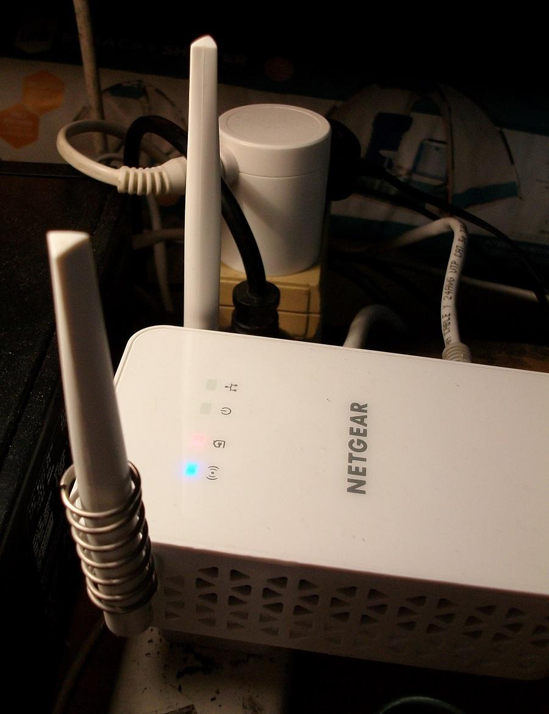
The presence of the spring will affect reception because it affects the antenna structure thus the emitting and receiving of the radio waves. The signals that are coming out of an antenna are microwave (MHz or GHz) frequencies. Thus there will be reflections of the signal going back inside the transmitter or receiver because of the spring. Those reflections could be caused by other materials near the antenna.

3. Conclusion

More research is needed to see how well this idea will work. I found that the presence of the spring did not improve the Wi-Fi reception. Improved reception is evident when your internet speed becomes faster because there is a better signal-to-noise ratio and fewer errors in receiving bits. Thus better reception eliminates the need for data to be transmitted again. If the correct bit value (that is either 0 or 1) was received due to high signal and low noise, this will save time for the network transmitter system, and make your internet work faster.

Adam from Crazy Circuits Project

